BSB NEWSLETTER

1 February, 2018

Certificates
Teachers appreciate those students who work hard, do well at school or do good things for others. To show that teachers notice when students do well either academically or socially, teachers have awarded them certificates.

18 January
Nursery: Salem
Reception: Khalifa and Osed
Year 1: Fouziyah
Year 2 Arabic: Amna and Masoud
Year 3: Dana, Farida and Mohab
Year 3 Arabic: Mohamed O.
Year 4 French: Lena
Year 5: Rimas K.
Year 5 French: Hameda and Zaid
Year 6 Mad Minute: Nikhilesh

25 January
Reception: Abdulsalea and Mousa
Year 1 Arabic: Zeinub
Year 2: Amna
Year 3: Osama
Year 4: Hoor
Year 5: Remas B.
Year 5 French: Remas B. and Sara
Year 6: Suliman
Year 6 Mad Minute: Thabit and Yomna

Upcoming Assemblies
- Year 3: Thursday, 8 February
- Year 4: Thursday, 15 February

Is a Tortoise a Turtle?
Yes, turtles are any shelled reptiles belonging to the scientific order Chelonii. The term "tortoise" is a more exact name; it refers to land turtles. Tortoises are usually herbivores and can't swim.
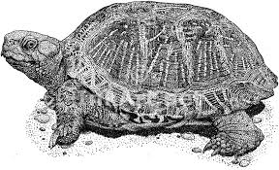

This is a tortoise.

How to read at home with children of any age

Research proves that children who enjoy reading do better at school in all subjects.

- Set aside some time
Find somewhere quiet without any distractions - turn off the TV/radio/computer.
- Ask your child to choose a book
Sharing books they have chosen shows you care what they think and that their opinion matters. This means they are more likely to engage with the book.
- Sit close together
Encourage your child to hold the book themselves and/or turn the pages.
- Point to the pictures
If there are illustrations, relate them to something your child knows. Ask them to describe the characters or situation or what will happen next. Encourage them to tell you the story by looking at the pictures.
- Encourage your child to talk about the book
Talking about the characters and their problems helps children understand relationships and is an excellent way for you to get to know each other or discuss difficult issues. Give your child plenty of time to respond. Ask them what will happen next, how a character might be feeling, or how the book makes them feel.
- And lastly, above all - make it fun!
It doesn't matter how you read with a child, as long as you both enjoy the time together. Don't be afraid to use funny voices: children love this!
www.booktrust.org.uk

Production
Ms Nafeesah wants to remind everyone in the play to:
- bring a flashdrive. Ms Nafessah will download the songs for you to practice at home.
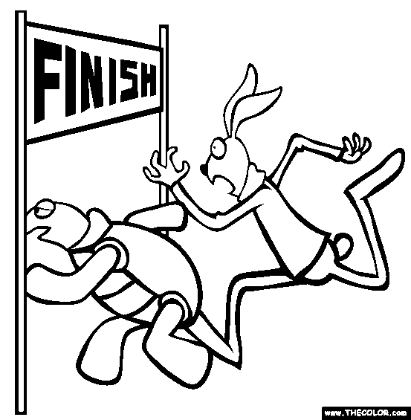
- memorise your lines.

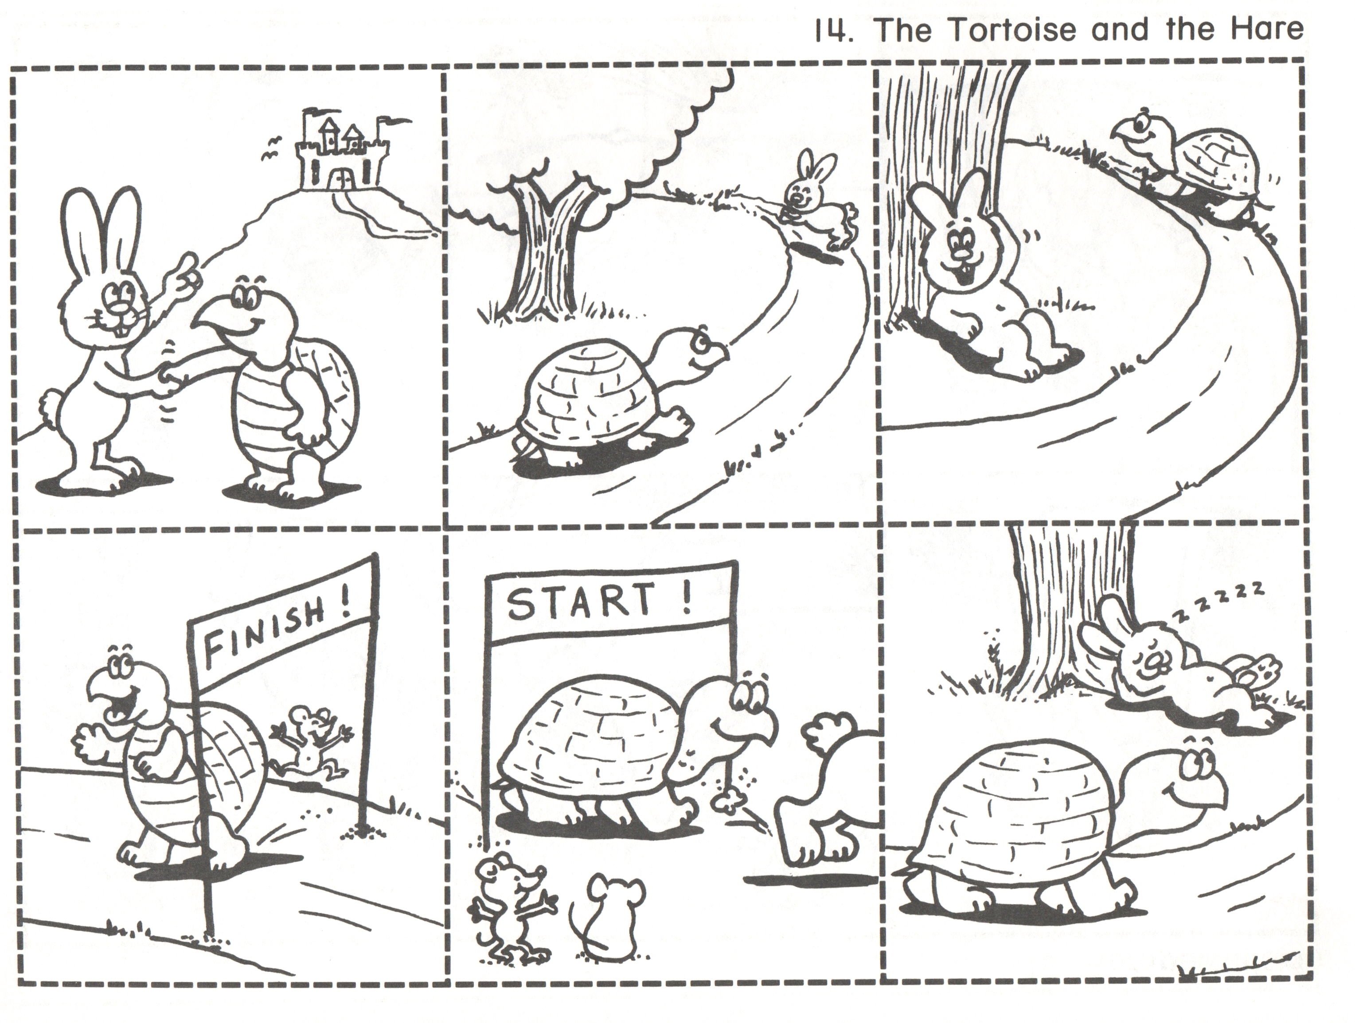
Cut out the pictures and put them in the correct order.

