BSB NEWSLETTER

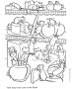

23 November, 2017

Certificates
Teachers appreciate those students who work hard, do well at school or do good things for others. To show that teachers notice when students do well either academically or socially, teachers have awarded them certificates.

9 November
Year 1: Youssef
Year 3: Mohamed Obeidi
Year 3 IT: Osama
Year 3 French: Osama
Year 4: Lena & Mostafa F.
Year 4 IT: Mohamed F.
Year 5: Rimas K.
Year 5 IT: Sarah
Year 6 Mad Minute: Nikhilesh

16 November
Nursery: Zaineb
Reception: Faraj
Year 2: Mohamed
Year 2 IT: Jad
Year 3: Alia
Year 4: Mohamed Fadeel
Year 5: Zaid
Year 5 IT: Remas Benamer
Year 6: Nikhilesh

Thank you to all parents who attended the parent-teacher conferences. It was good to see parents taking part in the education of their children. When working together, parents and teachers form an essential partnership in the education of children.

Home Time
If you make arrangements for your child to go home with someone other than the regular person who picks him/her up, please let the school know well before home time. You can call Ms Layla, tell your child’s teacher or write a note to your child’s teacher. It is important that we know that all children are safe and with the correct people.

Head Lice
You will have received a note regarding head lice. When children play, often head-to-head contact occurs. This is one way lice are transmitted from one student to another.
Many people become over-concerned with this natural occurrence. There is nothing to be alarmed about. However, parents should check their children’s hair for evidence of lice. If you do find lice in your child’s hair, ask your pharmacist for the most effective treatment; usually in the form of a shampoo. Follow the directions carefully, and check your child’s hair regularly.

After-School Activities Come to an End
Please make a note that the last day for after-school activities will be Wednesday, 29 November. Starting December, all students must be picked up at 2:10.

Assembly
The next assembly on Thursday, 30 November will be hosted by the Nursery and Reception students. Everyone is welcome to attend. The assembly will start at 1:40.

Reminder: School fees for Term 1 must be paid; this includes both the Dinar and Euro portions.

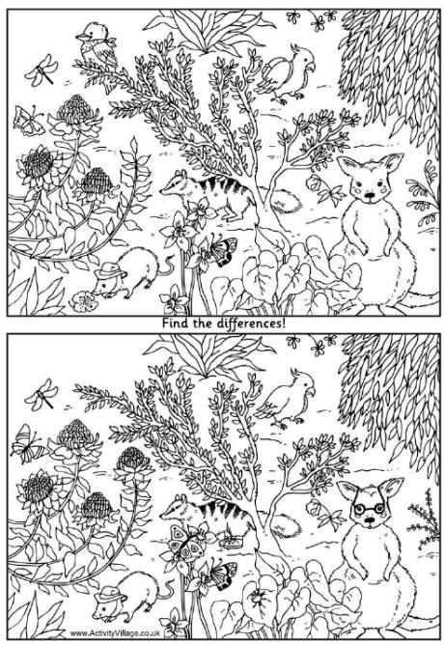

Remember: Check out newsletters and school photos on the school’s website
www.britishschoolbenghazi.org

